# Workshop Testing

**Main goal of this workshop**

Know the importance of creating iterations through user involvement. What can we learn from our user?

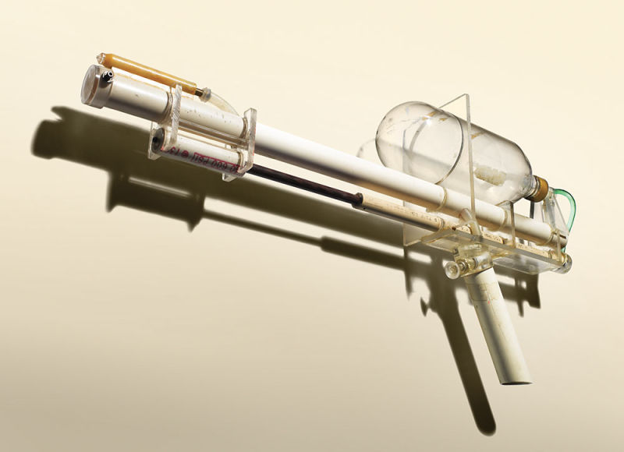

*The Super Soaker was invented in 1982 by engineer* [*Lonnie Johnson*](https://en.wikipedia.org/wiki/Lonnie_Johnson_(inventor))*. The prototype combined* [*PVC pipe*](https://en.wikipedia.org/wiki/PVC_pipe)*,* [*acrylic glass*](https://en.wikipedia.org/wiki/Acrylic_glass)*, and an empty plastic* [*soda bottle*](https://en.wikipedia.org/wiki/2-liter_bottle)*.*

**1. Do some research on (user) testing. 20 min. Make a conceptual mindmap.**

<http://maptini.com/>

<https://bubbl.us/>

YOUTUBE LINK A

[USABILITY TESTING FRUIT](https://www.youtube.com/watch?v=3Qg80qTfzgU) (USABILITY TESTING FRUIT / TAKE AWAY?)

YOUTUBE LINK B

[MEISJE KLEURPLAAT-APPLICATIE TEST](https://www.youtube.com/watch?v=9wQkLthhHKA)

(MEISJE MET KLEURPLAAT / TAKE AWAY?))

YOUTUBE LINK C

[JAKOB NIELSEN ON SIMPLE USER TESTING](https://www.youtube.com/watch?v=r0A6IW2TFFI)

(JAKOB NIELSEN ON SIMPLE USER TESTING / TAKE AWAY?)

YOUTUBE LINK D

[ALISTAPART USABILITY TESTING DEMYSTIFIED](http://alistapart.com/article/usability-testing-demystified)

(ALISTAPART USABILITY TESTING DEMYSTIFIED/ TAKE AWAY?)

**2. Study the Super Soaker. What aspects are there to test?**

*Functional or is there more? What questions do we have to ask our users?*

**3. Taste test**

Think of a soft drink company that wants to launch an entirely new soft drink. They need to test this drink.

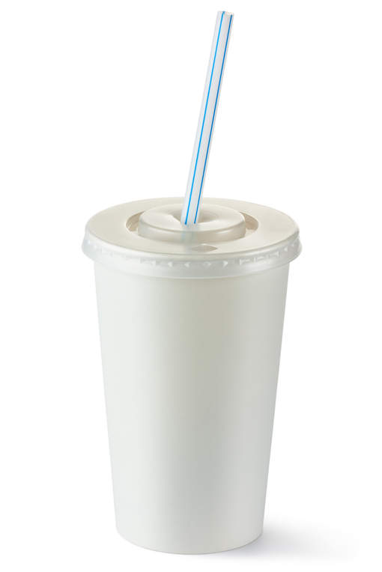

*Hoe about this packaging?*

- If you were allowed to ask the test person ONE question. What would it be?

- What are the answers you could expect?

- What do you know now? What don't you?

**4. Think of 5 questions to ask your user.** These questions may only be answered by YES or NO. What questions do you ask? 10 minutes.

**5. Think of 10 questions. They can be open questions.**

**6. Think of your Spotify concepts. Make a testing plan.** Research what this is first